Recursion Basics:

The link between Maths and Recursion:

PMI

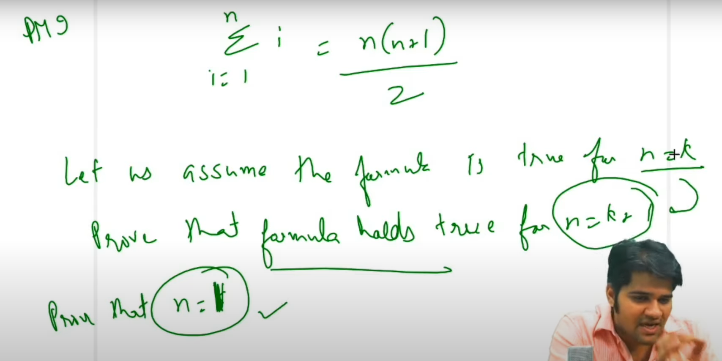

Suppose vrcha formula aplyala true prove karycha ahe

Below is the PMI method:

Step one … Let us assume that the formula is true for n = k

Step two … Prove that the formula holds true for n = k+1

Step three … Prove that the formula is true for n = 1

Once you have proven all these steps, it implicitly means that the formula is true for all the natural numbers

**How to actually think during solving a recursion questions?**

**Here we have to understand 2 types of thinking**

1. **High level thinking (Expectation, Faith , Faith se Expectation meet)** 
   1. **Do HLT for a particular example**
   2. **Generalize that**
2. **Low level thinking (stack and dry run)**

Ex: Print decreasing sequence using Recursion:

**Now we have to do High Level Thinking(HT)**

**Doing 1.1 High level thinking for a particular example i.e for n=5**

High level thinking che 3 steps as mentioned below

**Step 1 : Understand the expectation of your function**

Here: we have a function(PD) from which we expect that if we pass 5 , it has the ability to print 5,4,3,2,1

PD(5) // 5,4,3,2,1

**Step 2: Establish the Faith**

Here: We establish faith with our function that PD(4) automatically gives 4,3,2,1 … We don’t know how … But simply we believe

PD(4) : 4,3,2,1 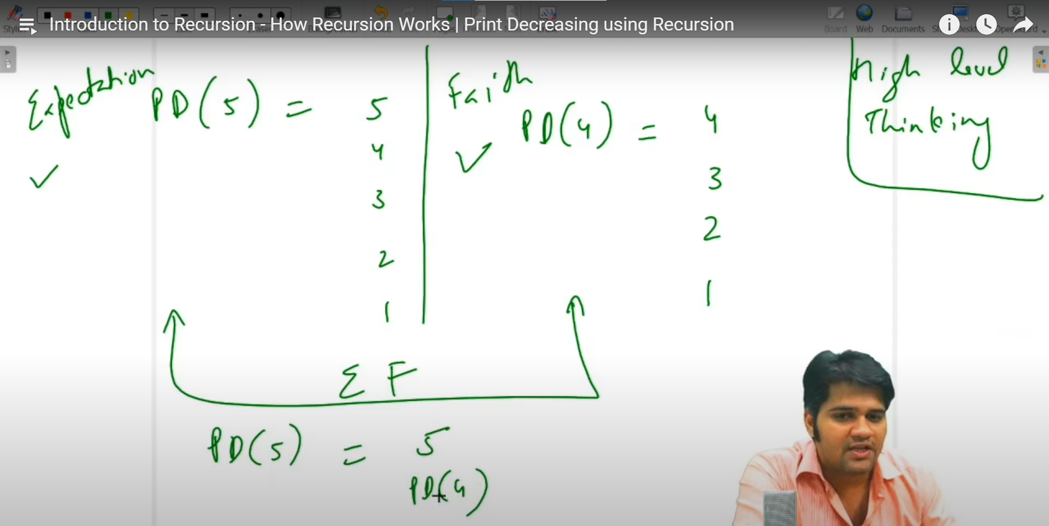

**Step 3 : Link Expectations and Faith**

PD(5) ni PD(4) karun kam kasa karvun ghetla pahije..

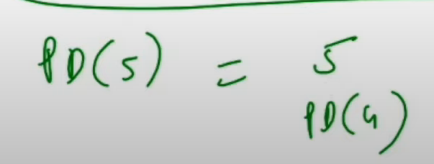

**Now doing High Level Thinking to generalize for ‘n’**

For that we will generalize the above steps for ‘n’

Khalchya image madhe PD(n) che 2 lines allele ahet bgh

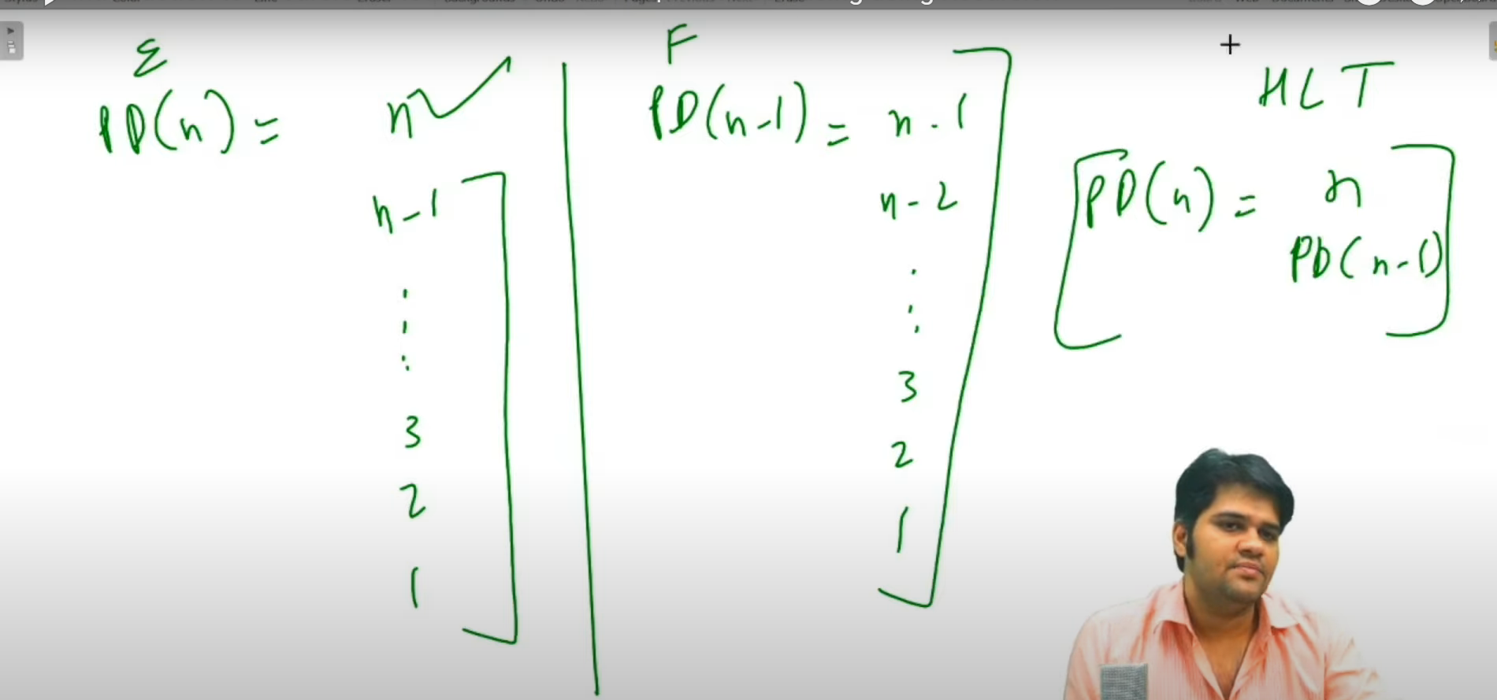

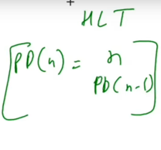

**Low Level Thinking**

**Do Low level thinking to find out the base case**

Here 0 nantr aplyala khalche number print karyche nahi ahet so 0 is our base case

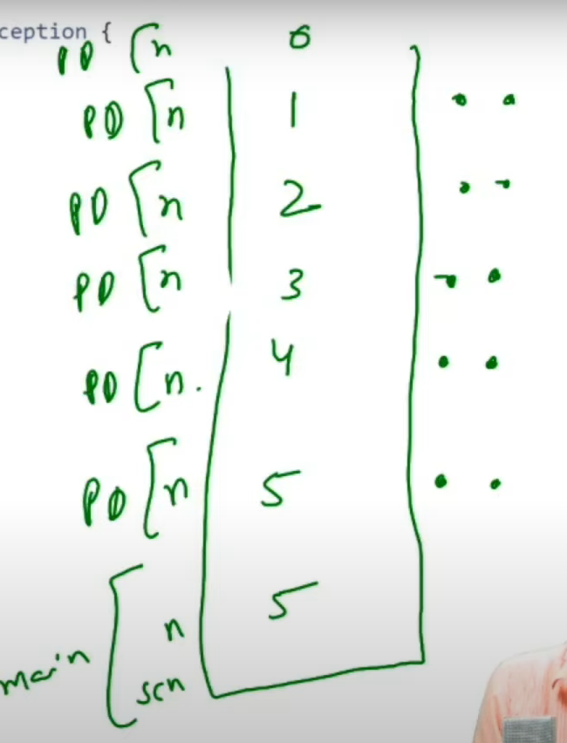

Dots in the image represents the lines inside the functions

**Low level thinking madhe stack madhe ekda run karun bghne/ dry run karne and then base case find out karne**

**Ek important insight in the context of Low level thinking(IMP)…**

Lines above the recursive call

**Recursive call()**

Lines below the recursive call

Lines stack madhe varti jatana call honar

Lines stack madhe Khalti jatana call honar

To better understand this see low level example of printDecreasingIncreasing

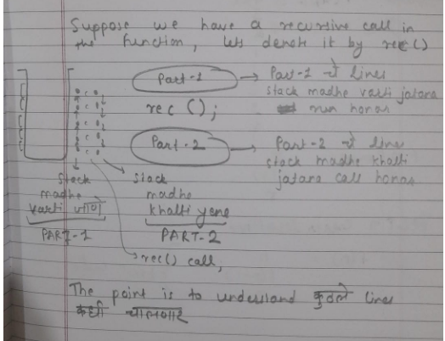

**To Summarise:**

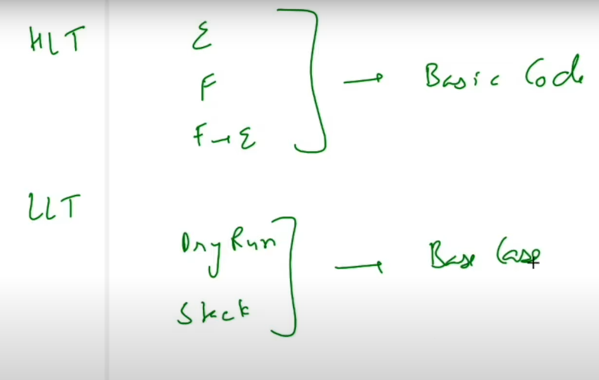

Ek implicit understanding : faith establish kartana nehmi ek number adicha kiva ek number nantrcha ghyaycha…

High level thinking mule aplyala ek basic code lihita yeto

Low level thinking mule aplyala base case identify karata yete